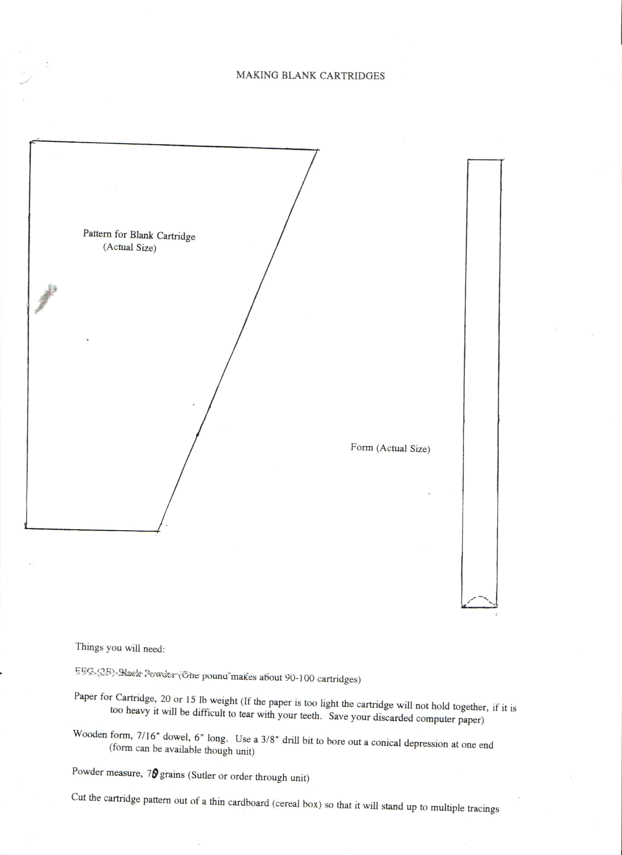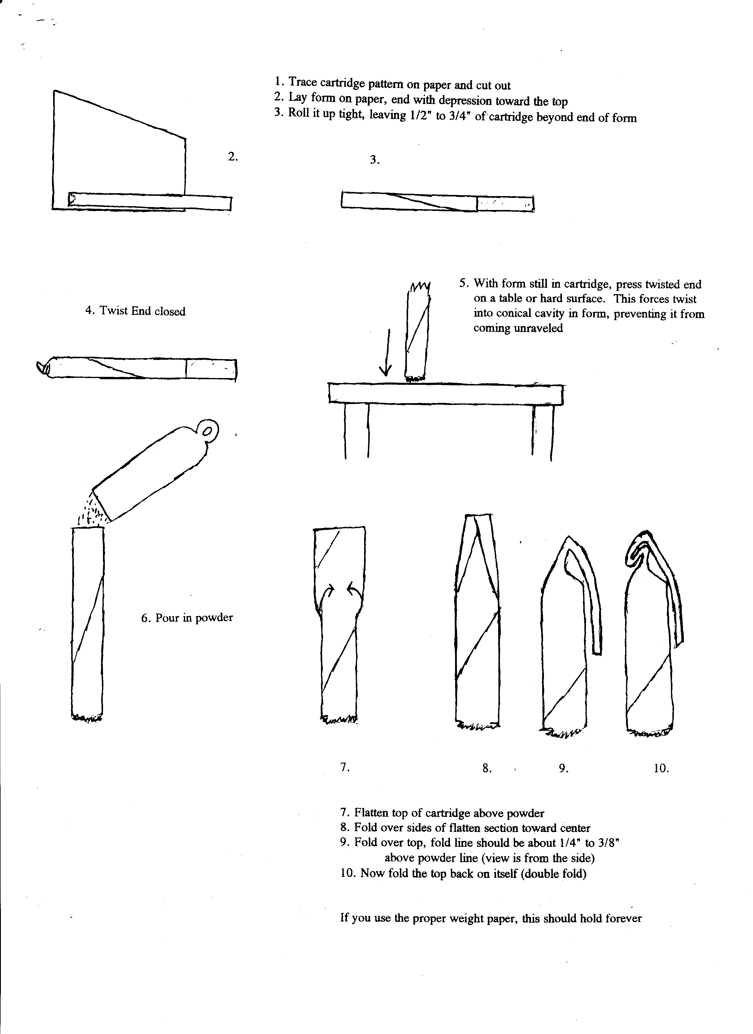
What you’ll need:

- FFG (2F) Black Powder (1 pound makes 90 to 100 cartridges)
- 15 to 20 lb. weight paper for making cartridges (Lighter paper will not hold together and heavier will be too difficult to tear with your teeth; newsprint and brown kraft work well)
- Template for making cartridge paper trapezoids (Use the pattern above to make one of thin cardboard that will stand up to multiple tracings)
- Wooden form: 7/16” dowel, 6” long. Use a 3/8” drill to bore out a conical depression at one end.
- Powder measure (set to approximately 60 grains)

